David L. Suddjian
Biological Consulting Services

801 Monterey Avenue, Capitola, CA 95010
Telephone 831· 479· 9603, email dsuddjian@aol.com

Summary of 2007 Marbled Murrelet Surveys
at “Girl Scout Creek” in Butano State Park,
San Mateo County, CA

Prepared for

California Department of Parks & Recreation

Prepared by

David L. Suddjian

Final Report
September 2007

Introduction

Dawn surveys for Marbled Murrelets (Brachyramphus marmoratus) were conducted in 2007 at a parcel known as “Girl Scout Creek,” recently acquired by the California Department of Parks and Recreation and included within Butano State Park (Figure 1). Prior surveys conducted in 2002 had confirmed that murrelets were present at the site, and sub-canopy flight behavior classified the site as “occupied” habitat where murrelets were likely nesting (Mori 2002).

Study Area

The Girl Scout Creek parcel is 80 acres in the west ½ of the northeast ¼ of Section 20, Township 8 S, Range 4 West, approximately 4.7 air miles from the ocean (Figure 2). It is located on the upper half of a west-facing slope of the canyon of Butano Creek, a perennial stream that is as close as 0.28 mi. to the study area. Elevations in the study area range from approximately 560 to 980 feet above sea level. Slopes vary from moderate to steep, and a low ridge divides the parcel into northern and southern portions. The southern part is drained by the stream known as “Girl Scout Creek,” a small perennial tributary to Butano Creek; the northern part is drained by two smaller unnamed intermittent tributaries of Butano Creek.

Most of the parcel supports coast redwood forest, with redwood, Douglas-fir and tanoak. Most redwood forest within the parcel is old growth, although its stature varies in different parts of the site. Much of the parcel’s old growth forest provide suitable nesting habitat for murrelets, with some areas providing high quality habitat with numerous potential nest trees. Higher quality habitat areas are generally those within 500 feet of two main drainages on the site, and more than 500 feet westward from the sites eastern boundary. Mixed evergreen forest dominated by Douglas-fir, tanoak, madrone, and California bay grows in the central part of the parcel near its eastern boundary. A small area of manzanita chaparral occurs along the south face of the central ridge, but it is being overgrown by mixed evergreen forest, and there is presently little open manzanita habitat. The site is surrounded by second growth coast redwood forest to the north, west and south, and along parts of the eastern boundary, and by mixed evergreen forest along most of the eastern boundary. In redwood forest areas the parcel boundary is readily evident in the forest structure due to the different harvest histories of the adjacent lands. Manzanita chaparral and knobcone pine forest occur on the main ridge east of the parcel.

An abandoned road runs near the eastern boundary of the site, and at least one haul road approaches the site along its western boundary. At least two well-marked trails run across the parcel, going down the slope from the abandoned road on the east side toward Canyon Road (Figure 2). There were signs of recent and regular mountain bike use of these trails (included development of technical features along the northern trail), but it is unknown how frequently the trails are used.

Additional “occupied” murrelet habitat occurs upstream in the Butano Creek watershed (Suddjian 1994 and 2003), including a relatively large area of habitat in the South Fork of Butano Creek. Occupied habitat also occurs in the Little Butano Creek watershed on the other side of the ridge southeast of the study area (Carter and Erickson 1992, Suddjian 2004).

Methods

Survey methods followed the approved protocol to detect presence or occupancy of Marbled Murrelets in forests (Pacific Seabird Group 2003). Each survey began 45 minutes before sunrise and continued to at least 75 minutes after sunrise. In addition to information about murrelets, notes were kept on all bird species recorded, and additional information was recorded on locations, numbers and activities of any known murrelet predators (e.g., corvids and raptors). Two 10 minute-long unlimited distance point counts were made during each survey.

Seven surveys were conducted at two stations in 2007, spanning May 9 to August 3 (Table 1). Four surveys were conducted at Station #1 located near the main “Girl Scout Creek” drainage (Figure 2). This was the same station sampled by surveys in 2002 (Mori 2002). Three surveys were conducted at Station #2, toward the northwest corner of the parcel (Figure 2). The parcel’s closed forest canopy offers limited options for survey station placement. Station #1 has a decent view of the sky to the north of the station, looking toward the drainage, where a tree fall has created a gap. It is surrounded by numerous potential nest trees. Station #2 has a more limited view of the sky, again to the north, with potential nest trees nearby.

Results

Thirty-four species of birds were recorded during surveys (Table 2). Marbled Murrelets were recorded on all seven surveys (Table 1).

Marbled Murrelets

Station #1. Station #1 had higher activity than Station #2, and had multiple sub-canopy flights recorded on three of the four surveys (Table 1). Sub-canopy flights were recorded at both stations, but there was only one such detection at Station #2, compared to 33 sub-canopy detections at Station #1.

Murrelet activity at Station #1 was dominated by detections of murrelets close to the station, with only a small number of auditory detections of murrelets passing in the distance. Most of the distant detections were oriented to the west or northwest of the station, beyond the boundary of the parcel, but some involved birds circling broadly over the parcel. The detections near the station involved repeated flights by members of one to two pairs of murrelets. They used flight corridors near the line of “Girl Scout Creek” and corridors between tree crowns right over the station. Some flew very low (as little as 30 feet above the ground), and several detections involved murrelets exhibiting remarkable agility as they flew through the branches of the tree crowns and executed tight turns at high speeds. Tree landings and aborted landings were recorded on three of four surveys. However, the details of these detections indicated that none of these involved landing at active nest sites.

Station #2.

Murrelet activity recorded at Station #2 was lower than at Station #1, with only one sub-canopy flight, and the majority of detections of birds calling in the distance. Thirty of the 35 total detections at this station were auditory detections of murrelets flying at distance of 200-600 meters from the station. Most were downslope to the west and northwest, with many circling in that area. Unlike Station #1, this station was not located near a canopy gap corridor that received regular use by murrelets. The lone sub-canopy flight was of a pair of birds that flew direct over the small viewing gap at the station, just below the tops of the surrounding trees.

Murrelet Predators

Bird species that are known or potential murrelet predators recorded in the study area during 2007 were Red-shouldered Hawk, Common Raven, and Steller’s Jay. Great Horned Owl was also heard one morning, but only in the far distance to the west.

Two Red-shouldered Hawks were heard from Station #1 on June 11, including one that was near the station; none were noted on other visits. Steller’s Jay was recorded daily, with 3-6 individuals heard during the each dawn survey. The whole parcel probably supports 6-9 nesting pairs. A pair of Common Ravens was active in the area in May and June, but no ravens were noted in July or August. This pair roosted east of the site near Butano Fire Road, and moved west toward Butano Creek at dawn, and then moved about generally in the area. One perched near Station #2 on June 22 was the only one seen close to the survey stations.

Discussion and recommendations

Patterns of murrelet activity at Station #1 were similar to those noted in 2002 (Mori 2002). Four dawn surveys conducted at Station #1 from July 10-24, 2002 recorded consistent activity and similar numbers of detections (4 to 59) as in 2007. The 2002 surveys also recorded sub-canopy flights and at least one tree landing. The lower activity at Station #2 might be due partly to that station’s position away from near proximity to any well defined tributary drainage.

Flight behaviors and the relatively high incidence of sub-canopy flights at Station #1 indicated that Marbled Murrelets likely nest in the study area, and habitat quality is high in parts of the parcel. The average activity level at Station #1 was robust compared to recent data from most places in the Santa Cruz Mountains (e.g., exceeding levels at Big Basin Redwoods State Park, and matching those on most surveys at Portola Redwoods State Park; D. Suddjian pers. obs.). However, observations indicated that multiple detections were created by up to two pairs of murrelets, so the number of birds currently associated with the parcel is probably small. Still, the “Girl Scout Creek” parcel is a valuable habitat element in the matrix of suitable habitat remaining in the Butano Creek watershed, and more broadly in the region.

Dawn surveys are planned to continue in 2008 and 2009, with seven in each year. It is recommended that coverage of Station #1 continue, with three or four surveys there annually, to provide a reference for current activity levels. The remaining three or four surveys (depending on how many are done at Station #1) should be conducted at other locations to sample activity elsewhere in the parcel and assess if there are other “hot spots” like Station #1. This approach will be contingent upon finding other station locations that provide at least some appropriate view of the sky, otherwise visual detections of murrelets will be very few, limiting useful information.

Given the site’s good habitat quality and relatively robust murrelet activity, careful consideration of management actions is warranted. Assuming there will not be actions taken to substantively change the nature of the forest habitat in the parcel, the primary management concerns relate to human uses that would attract murrelet predators or foster their populations. Potential for direct disturbance of murrelets due to human activity is minimal given the types and levels of use that might be anticipated in this case. Furthermore, the site already receives regular human uses, and it is not far removed from human habitations.

As a management plan is developed for the site, it is recommended that there be:

- No uses that would increase the level of human food brought into the area.
- No uses that would significantly increase human presence during the dawn or dusk periods.
- No installation of features (e.g., picnic tables, benches) that might promote park users to pause and consume food within the site.
- No development of sites for overnight camping.
- Restricted development of trails so that human activity is limited to select areas of the site, leaving most of it undisturbed.
- No development of public motor vehicle access to the immediate vicinity of the site boundaries, as these would tend to promote consumption of foods and deposition of garbage at those sites.

The same recommendations would benefit murrelets if they were applied, to the degree feasible, on adjacent properties within 0.25 mile of suitable murrelet nesting habitat.

The existing use of existing trails by hikers and mountain bikes probably has no detrimental impact to murrelets. Even an increase in use within the likelihood of what would be expected for a remote parcel would probably have no significant impact, provided the recommendations given above are observed.

Literature Cited

Carter, H.R. and R. A. Erickson. 1992. Status and Conservation of the Marbled Murrelet in California, 1892-1987. Proc. West. Found. Verte. Zool. Vol. 5 (1): 92-108.

Mori, B. 2002. Save the Redwoods League U.C. Regents Property 2002 Marbled Murrelet Study, San Mateo County, California. Prepared for Save the Redwoods League.

Pacific Seabird Group. 2003. Methods for surveying Marbled Murrelets in forests: a revised protocol for land management and research. Marbled Murrelet Technical Committee. Unpubl. report dated 6 January, 2003.

Suddjian, D. L. 1994. An assessment of forest use by the marbled murrelet and response to a selective timber harvest in the South Fork Butano Creek watershed, San Mateo County, California. Prepared for Big Creek Lumber Company.

Suddjian, D. L. 2003. 10 years of monitoring Marbled Murrelets at the South Fork of Butano Creek, San Mateo County, California, 1992-2001. Prepared for Big Creek Lumber Company.

Suddjian, D. L. 2004. Summary of 2003 Marbled Murrelet Surveys in the Santa Cruz Mountains. Unpubl. report prepared for Command Oil Spill Trustee Council.

Table 1. Summary of dawn murrelet surveys conducted at Girl Scout Creek in 2007.

Station Date Obs. Cloud Precip. Total # Occ.¹
Cover # Dets. Dets.

1 09 May 07 Suddjian 0% none 26 8
1 11 Jun 07 Suddjian 100% fog 23 10
1 08 July 07 Suddjian 100% fog 39 14
1 03 Aug 07 Suddjian 100% fog 11 1

2 20 May 07 Suddjian 0-100% fog 6 1
2 22 Jun 07 Suddjian 0% none 8 0
2 22 July 07 Suddjian 100% fog 21 0

1. Occ. Dets. = occupied site detection, i.e., detection murrelet(s) flying below the forest canopy or landing in trees.

Table 2. Bird species recorded during surveys at the Girl Scout Creek study area in May to August 2007.

** Evidence of confirmed nesting observed in the study area for species.
* Species likely nests in the study area, but confirming evidence was not obtained.

Turkey Vulture (Cathartes aura) **
Red-shouldered Hawk (Buteo lineatus)
Marbled Murrelet (Brachyramphus marmoratus) *
Band-tailed Pigeon (Patagioenas fasciata) **
Mourning Dove (Zenaida macroura) *
Barn Owl (Tyto alba)
Western Screech-Owl (Megascops kennicotti) **
Great Horned Owl (Bubo virginianus) [only heard
in the distance, well removed from study area]
Northern Saw-whet owl (Aegolius acadicus) *
Allen's Hummingbird (Selasphorus sasin) *
Acorn Woodpecker (Melanerpes formicivorous) *
Hairy Woodpecker (Picoides villosus) **
Northern Flicker (Colaptes auratus)
Pileated Woodpecker (Dryocopus pileatus) **
Pacific-slope Flycatcher (Empidonax difficilis) **
Hutton's Vireo (Vireo huttoni) *
Steller's Jay (Cyanocitta stelleri) *
Common Raven (Corvus corax)
Violet-green Swallow (Tachycineta thalassina)
Chestnut-backed Chickadee (Poecile rufescens) **
Pygmy Nuthatch (Sitta pygmaea) *
Winter Wren (Troglodytes troglodytes) **
Golden-crowned Kinglet (Regulus satrapa) **
Hermit Thrush (Catharus guttatus) **
American Robin (Turdus migratorius) *
Varied Thrush (Ixoreus naevius) **
Wrentit (Chamaea fasciata) *
Hermit Warbler (Dendroica occidentalis) *
Wilson's Warbler (Wilsonia pusilla) **
Spotted Towhee (Pipilo maculatus) *
Dark-eyed Junco (Junco hyemalis) **
Purple Finch (Carpodacus purpureus) *
Red Crossbill (Loxia curvirostra)
Pine Siskin (Carduelis pinus) *

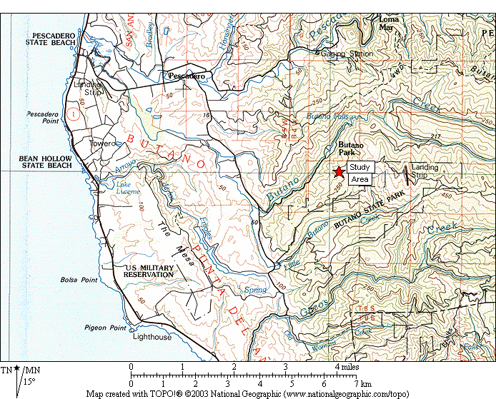

Figure 1. General location of the Girl Scout Creek study area (star). Other stands of occupied murrelet habitat in the surrounding region

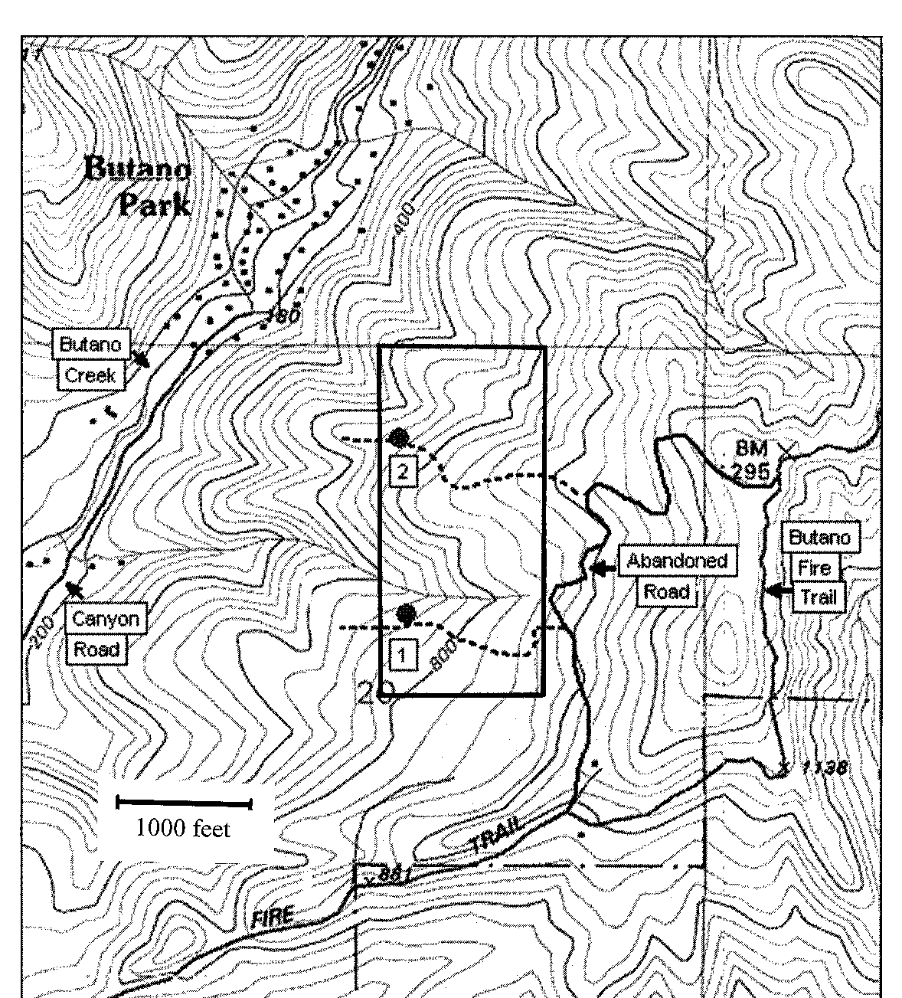

Figure 2. Girl Scout Creek study area, showing location of murrelet survey stations (circles) and the approximate routes of two existing trails on the site (dashed lines).

